1. Difference between Method overloading and method Overriding?

Polymorphism

*Technical:*

- ability of an object to take on many forms.

- types: compile-time Polymorphism(overloading), runtime Polymorphism (overriding)

- primary use: reusability.

Overloading - method, operator

- multiple methods within the class share the same name with different parameters.

Overriding - method

- Same method with same signature, but associated in a class & its subclass.

Constructor can be overloaded in a similar way as **function** overloading. Overloaded constructors have the same name (name of the class) but different number of arguments. Depending upon the number and type of arguments passed, specific constructor is called..

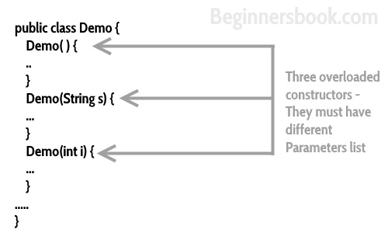

*Selenium:*

Some examples here:

Overloading method

- frame(int index), frame(String nameorid), frame(WebElement ele) of RemoteTargetLocator class

- moveToElement(WebElement ele), moveToElement(WebElement ele,int x,int y) of Actions class

- clickAndHold(WebElement target), clickAndHold()

Overloading constructor

When method has same name of class then it is called constructor.

RemoteWebDriver(), RemoteWebDriver(Capabilities capabilities)

Overriding

- ChromeDriver(C) has setFileDetector method and that overrides RemoteWebDriver(C) method

- InternetExplorerDriver(C) has getScreenshotAs method and that overrides RemoteWebDriver(C) method

*Project:*

In our customized selenium automation framework, we implemented overloading by:

- building multiple invokeApp methods like

a) invokeApp(String browser)

b) invokeApp(String browser, String url)

- and we did not implement any overriding as our design did not require it